Civil war in [Burundi]

UNSC Resolution: | 1049
Date of adoption: | 5-March-1996
Operative paragraph: | 7
Demand number: | 1049.0711

[Philippe Rieder]

Wording of demand
Cooperate fully with the Commission of Inquiry

List of addressees of the demand

Government of Burundi, National Council for the Defence of Democracy

Short-term compliance

Description of the addressee(s)’ conduct

“He [the Representative of Egypt at the 3693rd meeting held on 5 March 1996] stated that the OAU had played an important role in Burundi since 1993 and had sent an observer mission for dual political and military purposes and its military observers were providing protection to the officials of the international Commission of Inquiry. Even though that role was not initially welcomed by certain parties in Burundi and even though it received no political or material support from other international organizations it had become one of the major axes of development reaffirming the importance of the regional organization’s support for containing crises and conflicts under Chapter VIII of the Charter.” (The situation in Burundi, in: Repertoire of the UNSC 1996-1999, 13th Supplement – Chapter VIII, p. 19)

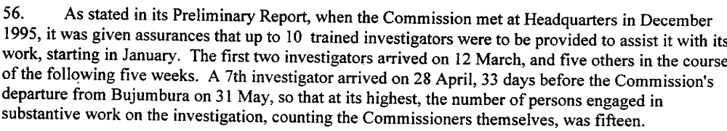
(Annex to Letter dated 25 July 1996 from the Secretary-General addressed to the President of the Security Council, transmitting the final report of the Commission of Inquiry,(S/1996/682), 22 August 1996, p. 15)

“She [the Representative of the USA at the 3693rd meeting held on 5 March 1996] stated that it was an initiative designed to bolster the confidence of moderates in the Government of Burundi and elsewhere in society and could save thousands of lives. She also urged the Secretary-General to provide additional security and investigatory personnel to the Commission of Inquiry since Commission needed to complete its investigation into the events of the attempted coup d’état of 1993 and the subsequent ethnic violence.” (The situation in Burundi, in: Repertoire of the UNSC 1996-1999, 13th Supplement – Chapter VIII, p. 20f)

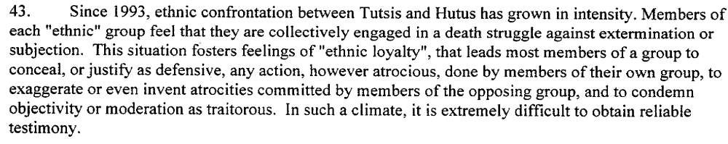
(Annex to Letter dated 25 July 1996 from the Secretary-General addressed to the President of the Security Council, transmitting the final report of the Commission of Inquiry,(S/1996/682), 22 August 1996, p. 13)

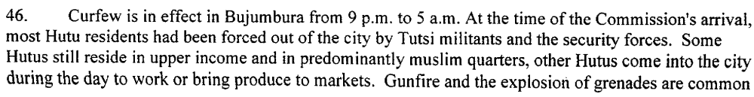
(Annex to Letter dated 25 July 1996 from the Secretary-General addressed to the President of the Security Council, transmitting the final report of the Commission of Inquiry,(S/1996/682), 22 August 1996, p. 13f)

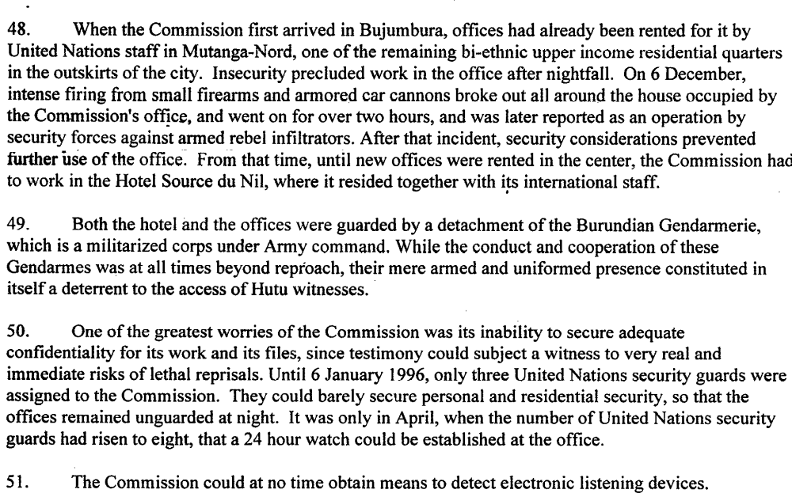
(Annex to Letter dated 25 July 1996 from the Secretary-General addressed to the President of the Security Council, transmitting the final report of the Commission of Inquiry,(S/1996/682), 22 August 1996, p. 14)

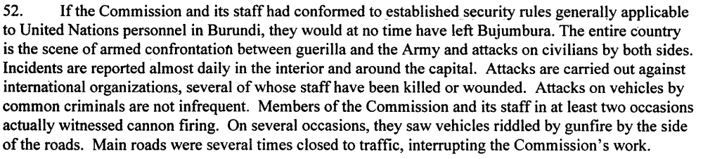
(Annex to Letter dated 25 July 1996 from the Secretary-General addressed to the President of the Security Council, transmitting the final report of the Commission of Inquiry,(S/1996/682), 22 August 1996, p. 14)

(Annex to Letter dated 25 July 1996 from the Secretary-General addressed to the President of the Security Council, transmitting the final report of the Commission of Inquiry,(S/1996/682), 22 August 1996, p. 15)

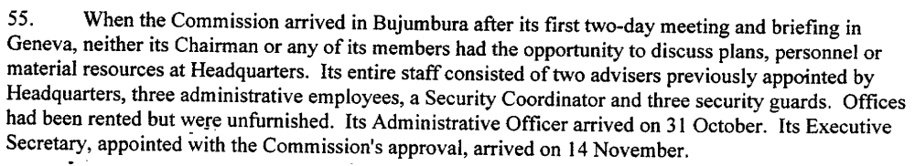(Annex to Letter dated 25 July 1996 from the Secretary-General addressed to the President of the Security Council, transmitting the final report of the Commission of Inquiry,(S/1996/682), 22 August 1996, p. 15)

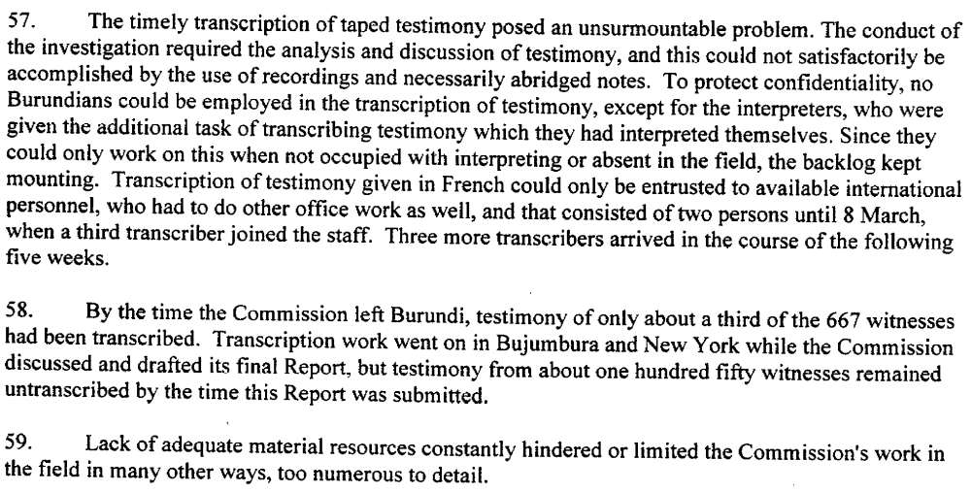
(Annex to Letter dated 25 July 1996 from the Secretary-General addressed to the President of the Security Council, transmitting the final report of the Commission of Inquiry,(S/1996/682), 22 August 1996, p. 15)

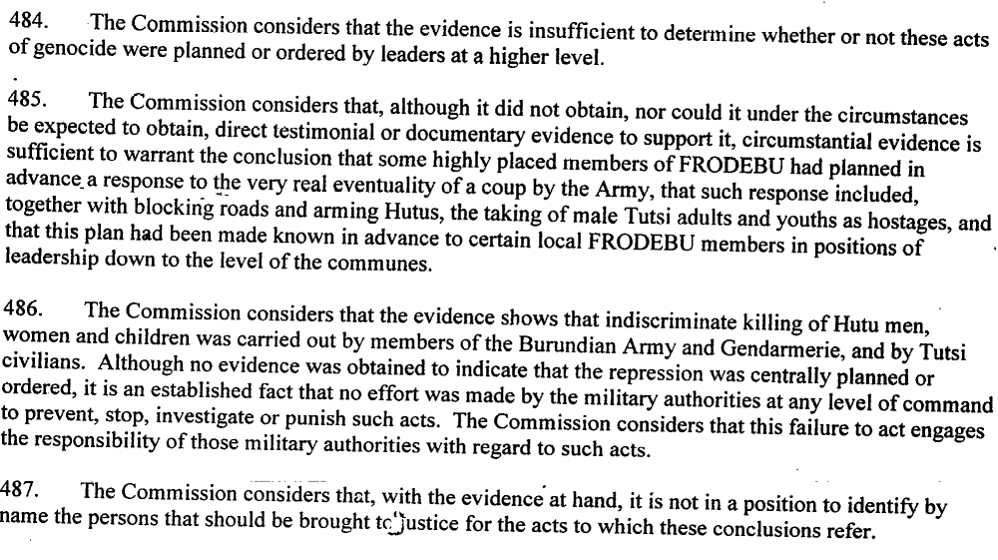
(Annex to Letter dated 25 July 1996 from the Secretary-General addressed to the President of the Security Council, transmitting the final report of the Commission of Inquiry,(S/1996/682), 22 August 1996, p. 74)

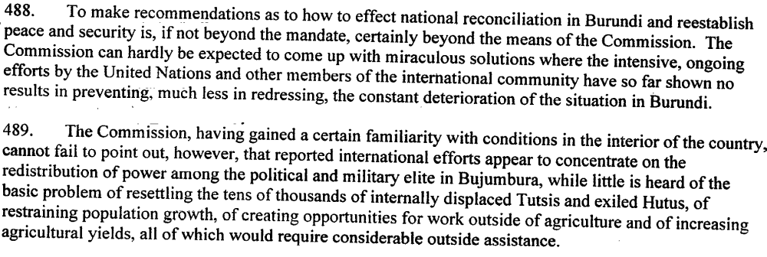
(Annex to Letter dated 25 July 1996 from the Secretary-General addressed to the President of the Security Council, transmitting the final report of the Commission of Inquiry,(S/1996/682), 22 August 1996, p. 74)
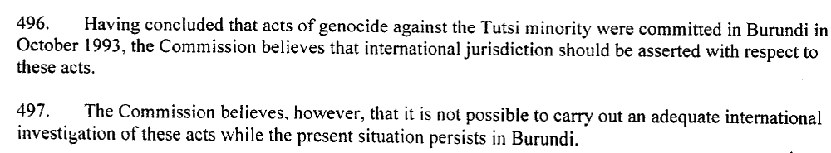
(Annex to Letter dated 25 July 1996 from the Secretary-General addressed to the President of the Security Council, transmitting the final report of the Commission of Inquiry,(S/1996/682), 22 August 1996, p. 75)

Assessment

Short-term compliance
No or marginal compliance (1) | X Medium low compliance (2) | Medium high compliance (3) | Full or almost full compliance (4)

Considerations underlying the assessment

Even though the Commission was able to travel to Burundi and was welcomed by the authorities there, its work was obstructed by the deteriorating security situation and the fact that it relied on the Burundese Security Forces for security, while the army of course was a party under investigation. Throughout the period of investigation, war raged inside Burundi. Ensuring the security of the Commission and allowing it access to certain areas was a dangerous task. Also, both sides did not want to have international witnesses to the massacres they committed.

Medium-term compliance

Description of the addressee(s)’ conduct

Assessment

Medium-term compliance
X No or marginal compliance (1) | Medium low compliance (2) | Medium high compliance (3) | Full or almost full compliance (4)

Considerations underlying the assessment

The Commission submitted its final report in August 1996. If there were no further investigations by it, there can’t be any compliance.
The Commission concluded its report with the remark that it did not think that further investigations would be possible, if the security situation remains precarious.

Depth of Demand

Assessment

Level of depth of demand
Low depth of demand (1) | X Medium depth of demand (2) | High depth of demand (3)

Considerations underlying the assessment

Level of confidence about coding decisions

Level of confidence about coding decision
Extremely high | High | X Moderate

Comments to IPI (if any)

